Grandstream Adds New Wi-Fi 6 Access Point to GWN Series
Today, Grandstream has announced the release of a new Wi-Fi 6 Access Point to the GWN Series. The GWN7664LR offers weatherproof casing and heat resistant technology, dual-band 4×4:4 MU-MIMO with DL/UL OFDMA technology and a sophisticated antenna design for maximum network through that supports 750 clients and an expanded
300-meter coverage range. The GWN7664LR is an ideal outdoor Wi-Fi access point for enterprises, multiple floor offices, warehouses, hospitals, schools and more.

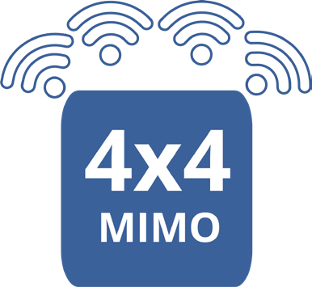Key Features

- 3.55Gbps aggregate wireless throughput, 2.5Gbps aggregate wired throughout
- Dual-band 4x4:4 MU-MIMO with DL/UL OFDMA technology

Self power adaptation upon auto detection of PoE or PoE+
- Support 750+ concurrent Wi-Fi client devices
- Up to 300-meter coverage range

Advanced QoS to ensure real-time performance of low-latency applications
- Anti-hacking secure boot and critical data/control lockdown
- Flexibility of 4 detachable/changeable antennas for different application scenarios
- Embedded controller manages up to 50 local GWN APs; GWN.Cloud offers unlimited AP management, & GWN Manager offers on-premise software AP management

Deployment Scenarios

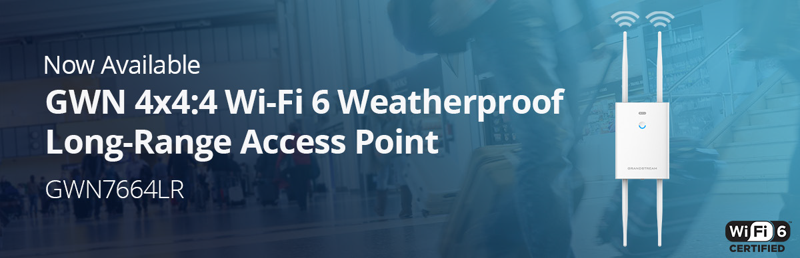


Public Spaces
The GWN7664LR is ideal for warehouses and factories looking to create a seamless Wi-Fi and communications environment to cover a large space with as little equipment as possible. GWN7664LR has up to
300 meter range allowing for more devices to be used on one access point throughout the whole facility and thanks to Wi-Fi 6 OFDMA and improved 4x4:4 MU-MIMO, helps manage more simultaneous IoT equipment.


Education

Parks, public spaces, stadiums and business centers who to offer Wi-Fi access to visitors and need to support a long-range network with hundreds of clients per device should consider GWN7664LR. Each device supports Wi-Fi 6 for faster data speeds, up to 750+ client devices, and 300 meter range. GWN series APs can be configured to create a mesh network in order to provide better coverage in hard-to-cover areas and create back- up in case an AP goes down.

Logistics
The GWN7664LR can be utilized by colleges, universities, and enterprises who are looking to provide indoor and outdoor Wi-Fi access to the whole campus and who need to access Wi-Fi across numerous devices concurrently. GWN7664LR supports the most advanced Wi-Fi standard, Wi-Fi 6, allowing it to be ideal for high-density Wi-Fi networks that require maximum speeds and client support and come equipped with IP66 weatherproof casing.

