Grandstream Adds New WiFi 6 Access Point to GWN Series
Today, Grandstream has announced the release of a new Wi-Fi 6 Access Point to the GWN Series. The GWN7664 offers dual-band 4x4:4 MUMIMO with DL/UL OFDMA technology and a sophisticated internal antenn a design for stronger anti-interference, more stable connection, maximum network throughput and expanded Wi-Fi
coverage range. The GWN7664 is also supported by GWN.Cloud and GWN Manager,
Grandstream’s cloud and on-premise Wi-Fi management platform.

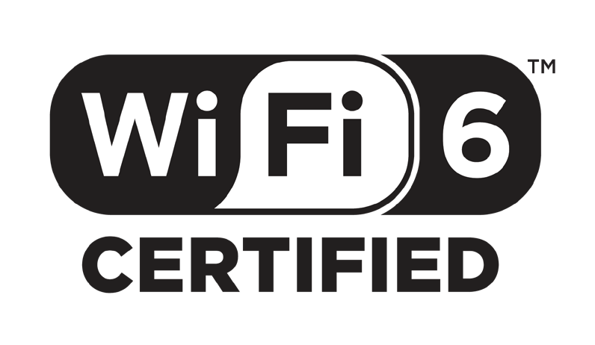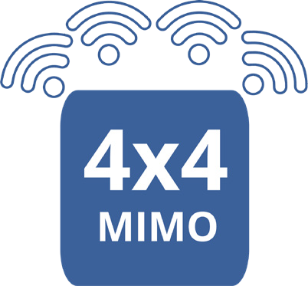4x4:4 MU-MIMO

WiFi 6 Certified

The GWN7664 is fully certified by the Wi-Fi Alliance. The Wi-Fi Alliance drives global Wi-
Fi adoption and evolution through thought leadership, spectrum advocacy and industry-wide collaboration. (Wi-Fi.org)
4x4:4 MU-MIMO with DL/UL OFDMA technology and a sophisticated internal antenn a design for stronger anti-interference, more stable connection, maximum network throughput and expanded Wi-Fi coverage range.

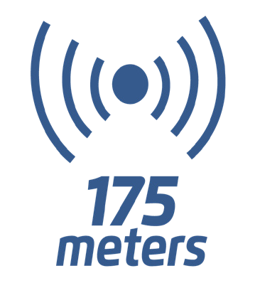Deployment Scenarios

Coverage

Up to 175-meter coverage range and supports
512 concurrent Wi-Fi client devices


Medium-Large Offices
Smaller sized offices who rely on Wi-Fi for most communications and need to support hundreds of simultaneous Wi-Fi connections while ensuring maximum quality for each connection should consider the GWN7664. This model supports Wi- Fi 6, which was designed specifically to maximize quality in dense Wi-Fi environments. It is ideal for businesses that rely on Wi-Fi for voice, video, data and mobility solutions.
Stadiums & Arenas

Ideal for any medium to large sized office complex that needs to provide the highest quality Wi-Fi speeds to ensure maximum productivity while supporting over 500 clients per device. Each GWN7664 supports up to 512+ client devices and each GWN series APs can be configured to create a mesh network in order to provide better coverage in hard-to-cover areas and create back-up in case an AP goes down.

Small Offices

A solution for colleges, schools, hotels and convention centers that are experiencing lackluster Wi-Fi network quality and rely on it for most communications can use the GWN7664 as it supports the most advanced Wi-Fi standard, Wi-Fi 6, allowing it to be ideal for high-density Wi-Fi networks that require maximum speeds and client support.

