Grandstream Adds New Wi-Fi 6 Access Point to GWN Series
Today, Grandstream has announced the release of a new Wi-Fi 6 Access Point to the GWN Series. The GWN7660LR offers dual-band 2x2:2 MU-MIMO with DL/UL OFDMA technology, IP66 weatherproof casing and a sophisticated antenna design for extended coverage range of up to 250 meters. The GWN7660LR is also supported by
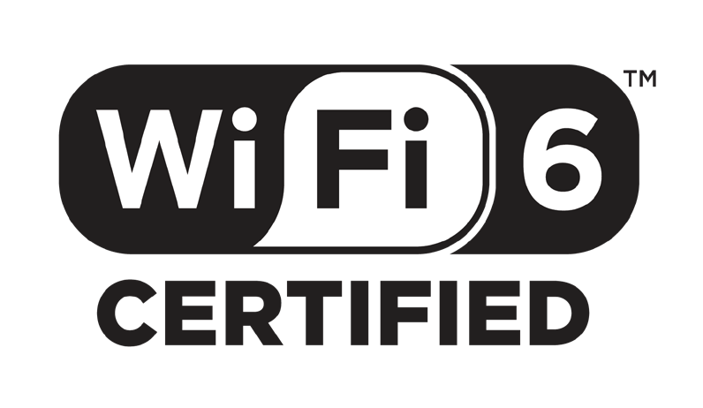GWN.Cloud and GWN Manager, Grandstream’s cloud and on-premise Wi-Fi management platform. It is the ideal Wi-Fi AP for voice-over-Wi-Fi deployments and offers a seamless connection with Grandstream’s Wi-Fi capable IP phones.

WiFi 6 Certified

The GWN7660LR is fully certified by the Wi-Fi Alliance. The Wi-Fi Alliance drives global Wi-Fi adoption and evolution through thought leadership, spectrum advocacy and industry-wide collaboration. (Wi-Fi.org)

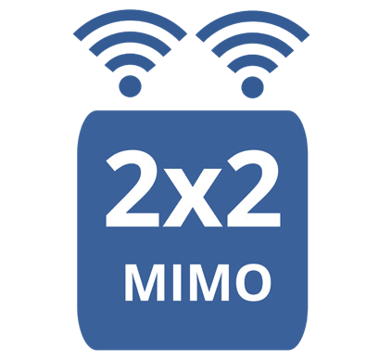2x2:2 MIMO
Dual-band 2x2:2 MUMIMO with DL/UL OFDMA technology, and 1.77Gbps throughput wtih 2x Gigabit Ethernet ports

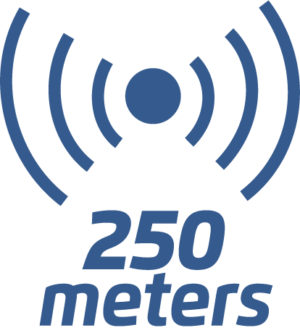Deployment Scenarios

Coverage

Up to 250-meter coverage range and Supports 256 concurrent Wi-Fi client devices


Public Spaces
The GWN7660LR is ideal for warehouses and factories looking to create a seamless Wi-Fi and communications environment to cover a large space with as little equipment as possible. GWN7660LR has up to
250 meter range allowing for more devices to be used on one access point throughout the whole facility and thanks to Wi-Fi 6 OFDMA and improved MU-MIMO, helps manage more simultaneous IoT equipment.


Education

Parks, public spaces, stadiums and business centers who to offer Wi-Fi access to visitors and need to support a long-range network with hundreds of clients per device should consider GWN7660LR. Each device supports Wi-Fi 6 for faster data speeds, up to 256+ client devices, and 250 meter range. GWN series APs can be configured to create a mesh network in order to provide better coverage in hard-to-cover areas and create back- up in case an AP goes down.

Logistics
The GWN7660LR can be utilized by colleges, universities, and enterprises who are looking to provide indoor and outdoor Wi-Fi access to the whole campus and who need to access Wi-Fi across numerous devices concurrently. GWN7660LR supports the most advanced Wi-Fi standard, Wi-Fi 6, allowing it to be ideal for high-density Wi-Fi networks that require maximum speeds and client support and come equipped with IP66 weatherproof casing.

