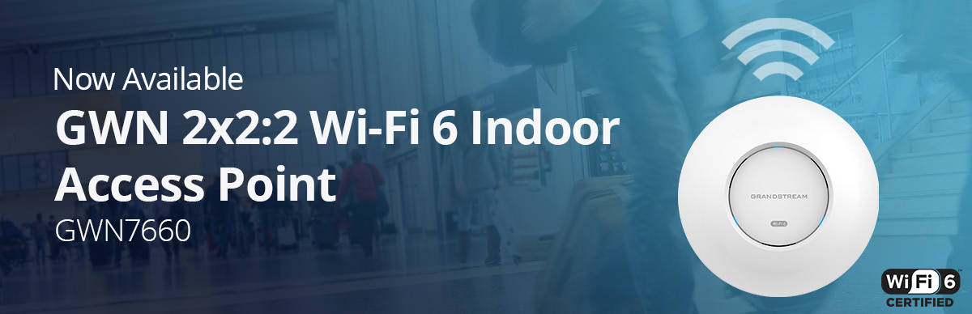


Grandstream Adds First WiFi 6 Access Point to GWN Series
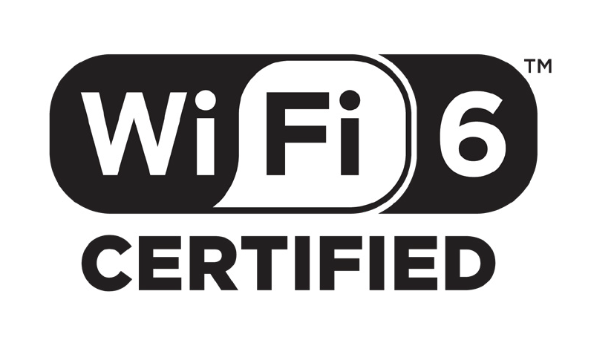Today, Grandstream has announced the release of a new Wi-Fi 6 Access Point to the GWN Series. The GWN7660 offers dual-band 2x2:2 MU-MIMO with DL/UL OFDMA technology and a sophisticated antenna design for maximum network throughput and expanded Wi-Fi coverage range. The GWN7660 is also supported by GWN.Cloud and GWN Manager, Grandstream’s cloud and on-premise Wi-Fi management platform. It is the ideal Wi-Fi AP for voice-over-Wi-Fi deployments and offers a seamless connection with Grandstream’s Wi-Fi capable IP phones.

WiFi 6 Certified

The GWN7660 is fully certified by the Wi-Fi Alliance. The Wi-Fi Alliance drives global Wi-Fi adoption and evolution through thought leadership, spectrum advocacy and industry-wide collaboration. (Wi-Fi. org)

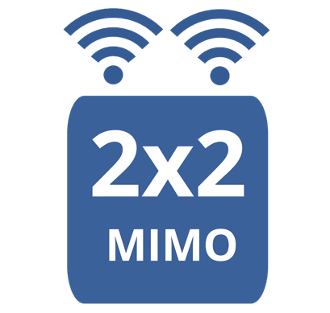2x2:2 MIMO
Dual-band 2x2:2 MUMIMO with DL/UL OFDMA technology, and 1.77Gbps throughput

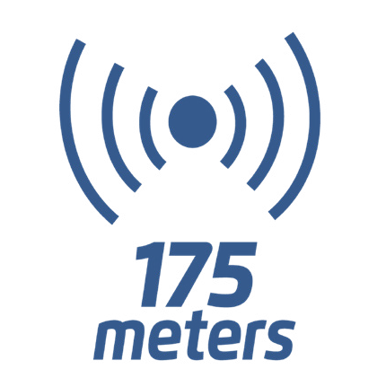Deployment Scenarios

Coverage

Up to 175-meter coverage range and Supports
256 concurrent Wi-Fi client devices

Ideal for medium to large offices who rely on Wi-Fi for most communications and need to support hundreds of simultaneous Wi-Fi connections while ensuring maximum quality for each connection. GWN7660 supports Wi- Fi 6, which was designed specifically to maximize quality in dense Wi-Fi environments. It is ideal for businesses that rely on Wi-Fi for voice, video, data and mobility solutions.
Medium-Large Offices

Hotels and convention centers need to support hundreds of users throughout large spaces while offering fast speeds
Hospitality
- which is what the GWN7660 was made to do. It utilizes the next-gen Wi-Fi 6 standard, supports mesh networks, and more.

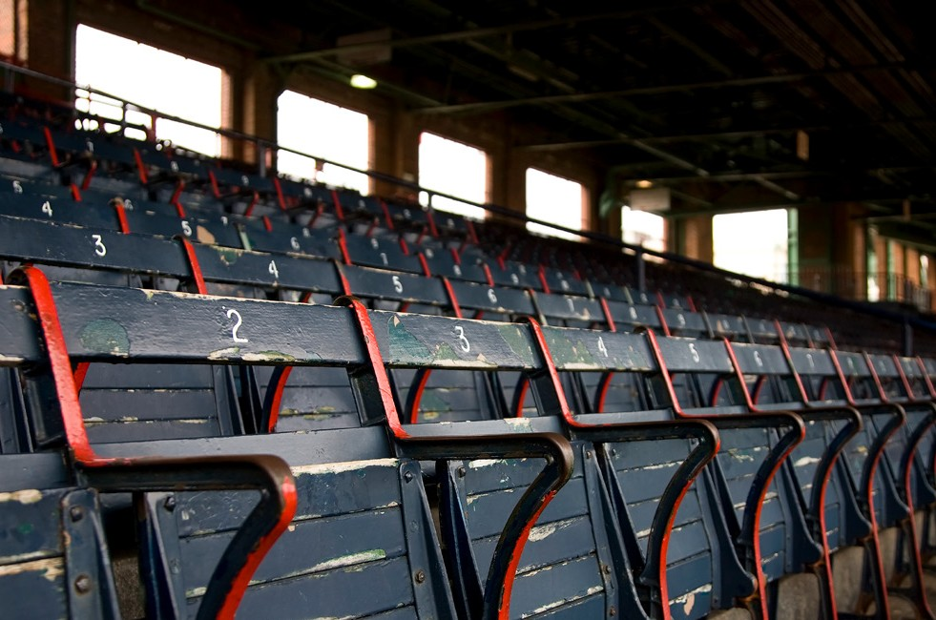Arenas and stadiums where there might be sports games, festivals, and concerts with dense crowds, looking to provide coverage and support to large numbers of client devices. Each GWN7660 supports Wi-Fi 6 for faster data speeds and up to 250+ client devices. GWN series APs can be configured to create a mesh network in order to provide better coverage in hard-to-cover areas and create back- up in case an AP goes down.
Stadiums & Arenas

