Grandstream Adds New Wi-Fi Access Point to GWN Series
Today, Grandstream has announced the release of a new Wi-Fi Access Point to the GWN Series. The GWN7625 is an 802.11ac Wave-2 Wi-Fi access point ideal for small- to-medium sized businesses, home offices, retail shops, restaurants and more. It offers 4x4:4 MU-MIMO technology on the 5G band and 2x2:2 MU-MIMO on the 2.4G band as well as a sophisticated antenna design for maximum network throughput and expanded Wi-Fi coverage range. The GWN7625 is the ideal Wi-Fi access point for medium wireless network deployments with medium user density.

Key Features

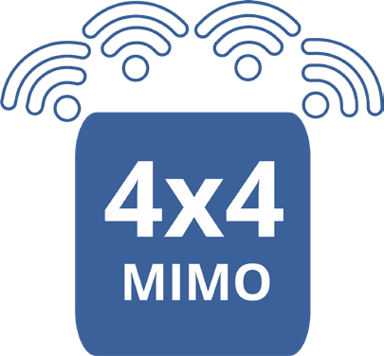

- 2.03 Gbps wireless throughput and 2 Gigabit wireline ports
- 5GHz 4×4:4 MU-MIMO
- Supports up to 200 concurrent Wi-Fi client devices
- Advanced QoS to ensure real-time performance of low-latency applications
- Anti-hacking secure boot and critical data/control lockdown via digital signatures, unique security certificate/random default password per device
- Self power adaptation upon auto detection of PoE or PoE+
- Embedded controller can manage up to 30 local GWN series APs; GWN.Cloud offers unlimited AP management; GWN Manager offers premise based software controller

Deployment Scenarios


Growing Business’
A small office looking for a
Wi-Fi solution that has an easy and affordable way to manage the device. Grandstream offers 3 FREE management options for the GWN series of Access Points. This includes, the embedded controller that can manage up to 50 local GWN series APs; GWN.Cloud offers unlimited AP management GWN Manager offers premise based software controller.
Retail & Restaurants
A small business is outgrowing their basic Wi-Fi solutions and wants to move towards a more powerful and scalable solution. The scalability of the GWN series allows any sized business to grow their network with their business growth. An office network needs to have the ability to start small with maybe one or two APs, but expand in their coverage and capacity as needed without having to overhaul or build an entirely new network.


Small Offices
Ideal for a retail shop looking for a Wi-Fi solution that can prioritize a network connection to specified devices. The GWN7625 allows for lower priority automation devices such as a printer, or lighting system to run on the 2.4 ghZ band, while devices such as pay systems, scanners, and security cameras can run on the other band in turn maximizing speeds for

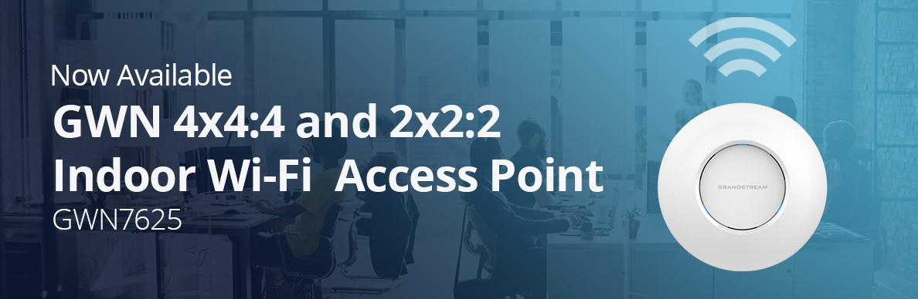
more critical devices.

